

***Mian Channu, Mohsin Wal***

***Https://*** [***www.shaheen47.com,***](http://www.shaheen47.com/) ***Email:*** [***imran.dodsal@gmail.com***](mailto:imran.dodsal@gmail.com)

***Ref. No. Date***

**TO WHOM IT MAY CONCERN**

It is certified that Mr. <Name> S/O <fname> has worked with us as a <Designation> at Jadeed Feed Mill Khanewal from <From2> to <To2>.

During this period, his services were found satisfactory. We wish him every success in his future life.

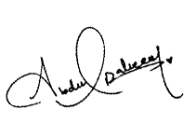

**Shaheen Engineering Works**